**April 2016 The Compassionate Friends Volume 30● Number 4**

***THE COMPASSIONATE FRIENDS***

**P. O. Box 50833 • Nashville, TN 37205 • (615) 356-4TCF(4823) •Nashville Website: www.tcfnashville.org**

Chapter Leaders: Roy and Barbara Davies, (615) 863-2052, email: tcfroyandbarbara@yahoo.com

Newsletter Editor: Melanie Ladd, (615) 513-5913, email: [melanierladd@gmail.com](mailto:melanierladd@gmail.com) Treasurer: Mike Childers, (615) 646-1333, email: [michaelc1333@gmail.com](mailto:michaelc1333@gmail.com)

Outreach: David Gibson, (615) 356-1351, email: davidg14@bellsouth.net

Regional Coordinator: Polly Moore, (931) 962-0458, email: [lolly39@aol.com](mailto:lolly39@aol.com)

***___________________________________________________________________________***

The mission of The Compassionate Friends is to assist families toward the positive resolution of grief

following the death of a child of any age and to provide information to help others be supportive.

***­­­­­­­­­­­­­­­­­­­­­­­­­***

*Welcome: The Nashville chapter meets at 3:00 p.m. on the second Sunday of each month in the American Builders & Contractors (ABC) Building, 1604 Elm Hill Pike, Nashville, TN 37210 . Park and enter at the rear of the building.*

*We truly regret that we have no accommodations for young children, but teenagers and older siblings are welcome to attend.*

**April 10 Panel Discussion on the**

**Phone Friends**

We have all experienced the pain of losing a child. We understand and would like to listen. If you can’t reach one of us, feel free to call another person on this list.

**Accidental Death** ………...Mike and Paula Childers

615-646-1333

**AIDS**………………….….…….….......Joyce Soward

615-754-5210

**Illness**………….…………..David and Peggy Gibson

615-356-1351

**Infant**…………………..……………..…Jayne Head

615-264-8184

**SIDS**………….…………..…….……KrisThompson

931-486-9088

**Suicide**…….……………….Ron and Darlene Henson

615-789-3613

**Small Child**….……........Kenneth and Kathy Hensley

615-237-9972

**Alcohol/Drug Overdose**......…...............……Ed Pyle

615-712-3245

**TCF National Conference**

A

national conference of The Compassionate Friends is unlike any

other conference you may ever attend. This conference provides fresh

insights, ideas, and a bond with other bereaved parents. The power of

attending a TCF National Conference is reflected in this quote:

*"I attended my first conference and it was one of the best things I have ever*

*done. The friends I made are incredible and the feeling throughout the*

*whole weekend was so healing. I never thought I would have to belong to*

*such a club, but am grateful it is there to help. Thank you TCF!"*

On April 10 a panel of our members will share with us their conference

experiences such as workshops, banquets, the sibling program and

The Walk to Remember and the ways conference attendance has helped

them in their grief.

Following this time together, we will break up into our small sharing

groups. Please join us.

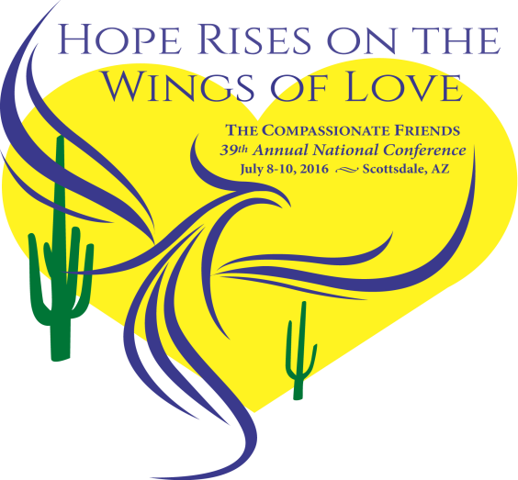

Attending your first TCF meeting can be difficult. Feelings can be overwhelming. We have all experienced them and know how important it is to take that first step. Please attend two or three meetings before deciding if TCF is right for you. There are no dues or fees. If you choose, you need not speak a word at a meeting. We are an international, non-denominational group, offering support and information to bereaved parents, siblings, and grandparents.

We Need Not Walk Alone.

Copyright © 2016 The Compassionate Friends. All rights

National Office P. O. Box 3696, Oak Brook, Illinois 60522-3696—Phone 630 990-0010 or Toll free: 1-877 969-0010

TCF Website: [www.compassionatefriends.org](http://www.compassionatefriends.org) National Office email:nationaloffice@compassionatefriends.org

**2 TCF Nashville, TN April 2016**

**A Dream Deferred**

C

hristine died on November 6, 1992. She was six years old and in kindergarten, but at 35 pounds and in size four clothes, she looked much younger. Brain-damaged before birth by hydrocephalus, she needed hours of occupational and physical therapy to learn to crawl, brush her teeth, ride her tricycle, zip her coat. I massaged her, coaxed her, pleaded with her, praised her—and watched her grow.

I never knew what skill might confuse Christine. She walked at thirteen months but did not crawl until fifteen months. She fed herself at eighteen months but could not hug herself until she was four. When she was two and a half, she was given a complete battery of tests. Her motor skills ranged from less than one year to average.

But Christine passed the speech test at a six-year-old level. At four she composed music and created lyrics to go with her melodies. She was a natural in math and, in true brat fashion, lorded it over her older brother who was not. “It’s OK that you’re not good in math,” she would tell Bobby. “Boys can’t do math.” Or she would walk up to him as he struggled over multiplication, point at a problem with her tiny hand, say, “That’s wrong. You’ll just have to do it again,” and run before he gave her a well-deserved slap.

Christine had so much potential. Her therapists, her teachers, her pediatrician, her neurosurgeon marveled at what she could do. She was humming nursery rhymes at thirteen months, humming Tchaikovsky at three. There were days when I had visions of Christine as an adult, leading an orchestra as they played her Seventh Symphony or on stage singing her latest Country and Western hit.

And then at six it was all over. Her music—her songs—turned off. My dreams muted.

And I found myself asking a question another poet in very different circumstances asked himself. What happens to a dream deferred? Does it merely fester? Or does it explode? (Langston Hughes, “Harlem,” 1953.)

Two seasons later I have a partial and paradoxical answer. It does both. It does neither.

These have been moments of intense anguish, when I marveled that my body could hold my mood and live. There have been times when sadness has softly sifted through my daily routines, shadowing my cooking and my speaking. But under both, deeper than the explosion of Christine’s unexpected death or the long sadness of her empty room, lies a certainty that Christine still exists, that we will one day be reunited.

A part of me crossed with her into death, still walks in love with her. Yet it is not a budding musician I walk with—or a brat—or a handicapped child. She was all of these. She is none of these. I walk with her. Her soul is whole now, bathed in light. Relationships fade and change. Love lasts.

Sandra Ball

TCF Salem, NJ

***Spirit Child***

*To my child who came into the world sleeping,*

*To my child whose little parts never fully grew,*

*To my child that I never felt move in my womb,*

*To my child that the world never knew.*

*Your heart will always beat through me.*

*I will think of you and ponder possibilities.*

*I’ll miss creating memories, but your heart will always beat through me.*

*To my child that I nourished,*

*To my child that fueled excitement, stretched my body, expanded my love space and made me glow,*

*To the child family never knew.*

*I will always cherish your conception.*

*To the child I never heard cry, and so often wonder why,*

*To the child that never opened your eyes to see the world into which you arrived, I may often question why.*

*To the child so light in weight whose dreams never took shape.*

*Your heart beats through me, cherished you will always be.*

*To the child planted in my womb,*

*To the child that did not have time to bloom:*

*You are the flower in my heart garden. Your seed will always and forever be.*

*My arms held you for a moment, for some moments never came.*

*But you are cradled in the heart, remembered always, missed often, loved forever. To the miscarried, still born, conceived in love, seed of my womb, my Spirit Child! Your Spirit lives!*

Pamela Hagens

TCF Nashville, TN

**April 2016 TCF Nashville, TN 3**

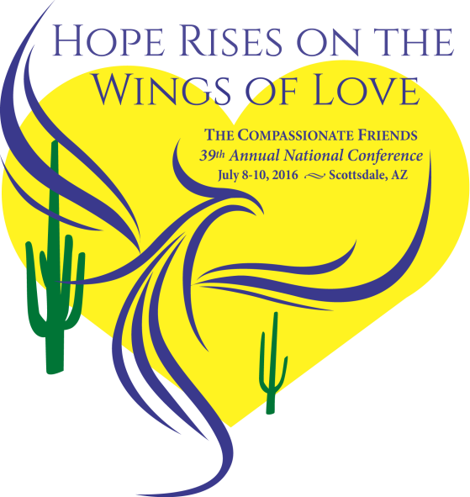

T

he Compassionate Friends is pleased to announce that Scottsdale, Arizona, will be the site of the 39th TCF National Conference on July 8-10, 2016. "Hope Rises on the Wings of Love" is the theme of next year's event which promises a great National Conference experience. The 2016 Conference will be held at the Fairmont Scottsdale Princess.

Details and registration can be accessed on the national website, www.compassionatefriends.org, as well as on the [TCF/USA Facebook Page](https://www.facebook.com/TCFUSA). Adult Registration (ages 18 +) $90.00 each*,* Child Registration (ages 9-17) $40.00 each

*Plan to be part of this heartwarming experience.*

***Thanks***

*Thanks to the friend who did know the right words to say: "There is a group in town that might help you."*

*Thanks to the parent who somehow found the courage to call that phone number and find out about "that group."*

*Thanks to the mother who went to that first meeting knowing it would really hurt to talk — and talked.*

*Thanks to the dad who said after the first meeting that he could never come back — but did.*

*Thanks to the parent who, at the fifth meeting, put her arms around a "new one" and said: "They really can help."*

*Thanks to the mom who, for the first time, was again able to bake cookies — for her "Compassionate Friends."*

*Thanks to the homemaker who could never talk in front of people — who became a facilitator.*

*Thanks to the six-foot father who cried in front of the other men — and didn't say he was sorry.*

*Because of you, we will be able to help someone we don't even know — next month.*

John DeBoer

TCF Greater Omaha, NE

Sorrow is like a precious treasure…

…shown only to friends.

African ProverbMCj03379620000[1]

**4 TCF Nashville, TN April 2016**

**That First Compassionate Friends Meeting**

T

his article is for those of you who are working up the courage to attend your first TCF meeting. Recently, some people who came talked about the effect their first meeting had on them and why they continue to attend. One couple said they felt so drained and unsettled they could hardly sleep and just dragged through work the next day. Another, a teacher, said that after her first meeting, she made arrangements to have a substitute teacher for her class the day following the second meeting she was going to attend. She knew she wouldn't feel up to teaching after coming to TCF. One man said he got up on the Tuesday morning of the week TCF met dreading having to go. He dreaded it all day, naming to himself many good reasons why he couldn't be there. Then he said he always felt better after the meetings and was glad he had made himself go. These examples show why we say, *"Try TCF two or three times before you give up on it."*

You may be asking yourself why someone would willingly attend a meeting that had such a seemingly bad effect and apparently left them more upset than when they came. Psychologists say we need to talk, feel and act in order to resolve grief in a positive way, so the lasting effects are beneficial to our functioning well and to our eventual healing. To heal we must have the courage to face reality and to change.

People continue to come to TCF, even if their first meeting turned them off, because they sense these things and they see a group of people who are individually coping and struggling to make peace with one of the worst traumas they will ever encounter. Initially they may feel worse because for two hours they've dealt with their grief in a concentrated way. They haven't been able to avoid it, push it to one side, be distracted by other things or deny the death of their child. They've told their story; they've listened to other people tell theirs; they've hurt for others, for themselves and for a world in which death has inverted the natural order of things. They've gotten a bucket load of grief all at once. No wonder they feel overwhelmed.

For many, the idea of group grieving is uncomfortable. They've treated their grief as personal (and it is), they've been self-centered (most grievers are), they've wrapped themselves in a cocoon of not being understood and feeling different from normal people, and they've bought society's myth that the repression of feelings is a sign of strength. Then here they are in a group of strangers who're spilling their guts. If they continue to attend, they may find "those people" aren't really strangers. They share a common bond. They, too, may have been uncomfortable at first, but as time went on, they found that a TCF meeting is the one place where it is safe to crawl out of that cocoon and talk about those unusual, crazy thoughts and actions that plague them.

Another thing that may bother people is that some TCF members actually laugh and socialize. Laughter is a great balm for tension and indicates that a certain amount of healing is taking place. People at TCF are in all stages of grief. Their laughter and socializing means they're making progress. It shows that all bereaved parents may one day want to laugh again, that grief will not be all encompassing.

Because you are so raw and vulnerable since your child died, certain meetings may anger you or hit your most tender spots. TCF does have off-nights when nothing comes over as intended, the speaker isn't on target, the sharing groups don't jell, the vibes are all wrong. Don't judge the possible benefits by one attendance. Consider, too that it might have been an off-night for you, or maybe you are attending too soon after your child's death and need to wait a while before coming back.

Time alone will not heal the wounds of the bereaved. It will distance you from the event, but it will not make you well. Acknowledging the death and the possibility for positive change, actively working to resolve the upheaval caused by the death and finding new avenues and persons to invest in and love will produce healing. TCF attempts to help as you reshuffle your life and work through your pain.

Grief is hard work; that's what TCF is all about. If, after attending several meetings, you feel TCF isn't for you, stop coming. It truly isn't for everyone, but the group is there if you need them, whenever you need them.

Elizabeth B. Estes  
*We Need Not Walk Alone,* the national magazine of

The Compassionate Friends*.*Copyright 1999-2010

***SEARCHING . . .***

*Once again, my list has vanished;  
it was here, but now it's missing.  
Keys and glasses disappearing;  
books and letters--overdue.  
I'm forever searching, searching,  
they must be here, and I need them!  
Could it be that what is missing,  
what I want this very minute--  
could it be that what I'm REALLY searching for,  
my child,  
is you?*

Joyce Andrews

TCF Sugar Land, TX

**April 2016 TCF Nashville, TN 5**

**CHAPTER INFORMATION**

**The Birthday Table**

In the month of your child’s birthday, a table will be provided at our meeting where you can share photographs, mementos, your child’s favorite snack or a birthday cake, a bouquet of flowers—anything you’d like to bring. We want to know your child better, so please take advantage of this opportunity to celebrate the wonderful day of your child’s birth and for us to become better acquainted.

**What is the Yellow Slip?**

Please return your yellow renewal slip. After a year on the newsletter mailing list, those names that were added in that month of a previous year, may receive a yellow half-sheet asking that their subscription be renewed. This is simply to keep our mailing list and the information in it current. If you do not send the yellow slip back, we must assume that you no longer want the newsletter. Although you are given an opportunity to make a voluntary donation, there is no cost involved in your subscription. The newsletter is our gift to you for as long as you wish to receive it. You may request that your name be returned to the active list at any time simply by calling 615-356-4TCF (4823).

**Religion and TCF**

The Principles of The Compassionate Friends state that TCF reaches out to all bereaved parents across the artificial barriers of religion, race, economic class, or ethnic group. Further, TCF espouses no specific religious or philosophical ideology. Despite our nondenominational status, many writers indicate that they have found comfort in their faith, and some have shared their anger and loss of faith. The opinions and beliefs expressed in letters, articles and poetry are those of the contributors.

**Newsletter Deadline**

All donations and original poems or articles for the TCF Nashville newsletter must be received by the meeting day of the month preceding the publication month. All donations and submissions are greatly appreciated.



**BEREAVEMENT RESOURCES**

**Survivors of Suicide**

There is a caring SOS group in Nashville. For information about meetings, you may call 615 244-7444, or go to the Tennessee Suicide Prevention Network at TSPN.org, and you will find a list of all Tennessee SOS locations.

**Sharing**

SHARING is a community organization interested in helping parents who have experienced a miscarriage, stillbirth or the death of a newborn infant. Call 615 342-8899 to confirm dates and times of meetings. See www.nationalshare.org.

**Alive Hospice Support Group for Bereaved Parents**

For general information about Grief Support Services at Alive Hospice, please call the main number: [615 963-4732](tel:615%20963-4732) or email [griefsupport@alivehospice.org](mailto:griefsupport@alivehospice.org). Diane Castellano, LCSW is a grief counselor there for children and their families. Call her at 615-346-8554. Contact John Baker at 615-346-8364 for bereaved parent support or individual counseling.

**Other TCF Chapters**

There are several other chapters of The Compassionate Friends you might want to know about. Anytime you are in their vicinity or feel the need to talk with other bereaved parents, feel free to attend their meetings. Also, when you personally know a newly bereaved family in one of these towns, please call the chapter number and give them the information so they can make contact with the family. To locate a chapter, you may call the TCF National Office at 1-877 969-0010, or go to [www.compassionatefriends.org](http://www.compassionatefriends.org) and click on chapter locator.

**6 TCF Nashville, TN April 2016**

**Donations to TCF—How they are used**

A

s a bereaved parent, there is so little we can do to commemorate the life of our child, but by giving a contribution to The Compassionate Friends in loving memory of a child or someone else, you are honoring the memory of that person and at the same time, helping to fund the work of your TCF chapter.

Why does a grief support group need financial help? In order to find the newly bereaved and to provide the kind of caring that the Nashville Chapter of The Compassionate Friends gives to bereaved families in this community, there are expenses of which you may not be aware.

Here are some of the ways your donations are used:

1. Brochures and articles concerning grief and TCF are supplied free of charge for the newly bereaved as well as professionals (hospitals, therapists, first responders, clergy, teachers and school counselors.)
2. Stationery, envelopes, labels, donation acknowledgement cards, bookplates
3. Postage and P. O. Box rental (letters, reports, and the monthly newsletter)
4. Paper for the newsletter (Allegra Printing provides the printing of our newsletter free of charge.)
5. Helpful books for the chapter library
6. Meeting supplies—name tags, registration cards and pens, birthday table setups, basic refreshments (drinks, snacks, cups, plates, napkins)
7. Telephone/Answering service
8. Program expenses such as videos, balloons and helium for the June meeting, candles and supplies for the December memorial service, bookstore gift cards for special speakers
9. Annual Membership fee and extra support given to the national organization

Your donations are very carefully used, and we thank you very much for helping to keep your Nashville TCF chapter one of the strongest and most successful in the nation.



Daffodil Time

S

ometimes in our grief we become workaholics. We rush, rush, and rush, never stopping to “smell the roses.” We are afraid that if we stop, or even slow down just a little, all those memories and thoughts of our dead child will come flying back, and we’ll drop down to that black hole of grief again—so we don’t stop or even slow down a little.

When I was in the fifth grade we had to memorize some poetry. I still remember lines from the poem “Daffodils”: “*When oft upon my couch I lie, in vacant or in pensive mood, They flash upon that inward eye, Which is the bliss of solitude.”* For a couple of years after my daughter’s death I could not, I would not allow myself to get into a vacant or pensive mood, because it wasn’t daffodils that flashed upon my inward eye, it was always my daughter who was there—and there was no bliss.

Things change. Time helped to heal the raw open wound. Now, after four years, I can allow myself to have those vacant or pensive moods, and I can see the daffodils along with my daughter. My bliss is bittersweet, sometimes more bitter than sweet, usually more sweet than bitter, but it is bliss as those memories flash upon my inward eye. I have accepted that which cannot be changed. I do NOT like it; I have accepted that she is dead. As I lie there, in vacant or in pensive mood, I am careful that those memories that I allow to flash upon my inward eye are the happy ones, not the sad or unhappy ones. They are more like roses than daffodils, though. They do have thorns that hide just below the beauty. But I can do it now. I can take time to “smell the roses.” And so can you. Try it. In small doses at first, then larger ones. You owe it to yourself—and to your family—and to your child.

Tom Crouthamel

TCF, Sarasota, FL